**Unit 11: Univariate Statistical Data**

**Lesson 1: what is Statistics?**

**Objectives:**

* I know the basic terms I need to know for our statistics unit.
* I understand the difference between qualitative. Quantitative
* I understand the difference between univariate and bivariate data
* I understand the difference between Biased and unbiased data.

**Agenda:**

* Definition search
* Practice
* Discussions

**Focus Question:**

* What is Statistics?

**Vocabulary:**

Biased/Unbiased, Qualitative/Quantitative, Population/sample, Univariate/bivariate

**Homework:** Homework sheet 11-1

**Web support:**

* <https://www.khanacademy.org/math/statistics-probability/displaying-describing-data/statistics-overview/e/statistical-questions>
* <http://study.com/academy/lesson/whats-the-difference-between-populations-and-samples.html>

**Web practice:**

* <http://study.com/academy/practice/quiz-worksheet-bivariate-data.html>
* <http://study.com/academy/practice/quiz-worksheet-random-selection-random-allocation.html>

**Warm up:**

In our day to day activities, we deal with many problems that involve related items of numerical information called **data**. **Statistics** is the study of sets of such numerical data. Often in order to study the data, we represent it graphically. There are many visual representations of data sets, such as:

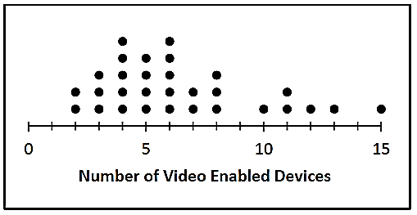

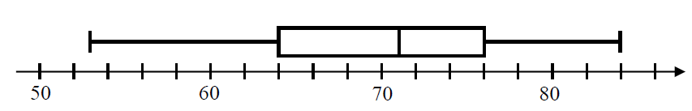

**dot plots box plots**

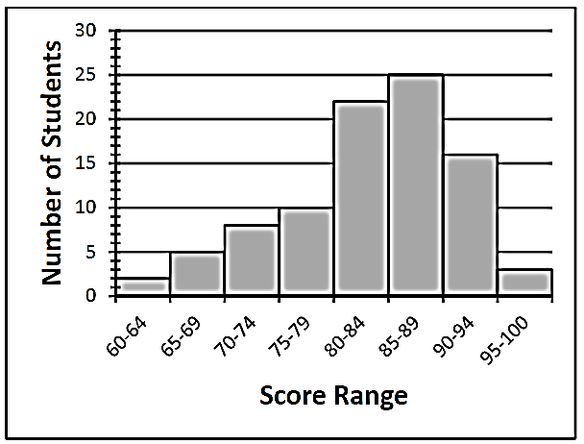 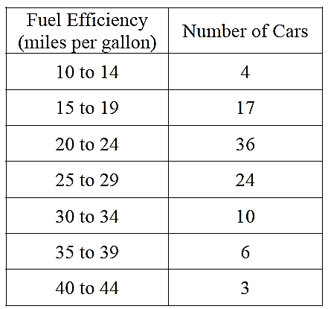

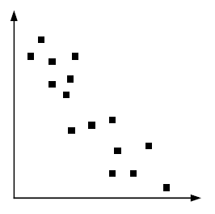

**frequency tables histograms scatter plots**

**Click on the link below to learn some vocabulary for the Unit.**

[**https://www.youtube.com/watch?v=VmlVhio2jHM**](https://www.youtube.com/watch?v=VmlVhio2jHM)

|  |  |
| --- | --- |
| 1. Population: | 1. Sample: |
| 1. Univariate data: | 5. Bivariate data |
| 1. Qualitative data: | 7. Quantitative data: |
| 8. Biased data: | 9. Unbiased data: |

**Practice:**

**Determine the population or sample in the following scenarios:**

|  |  |
| --- | --- |
| 1. A beverage company wanted to see if people in the United States liked their new logo. Which choice **best** represents a population?   A. A selection of logo artists.  B. Every person in the United States.  C. A selection of shoppers from different states.  D. 3,800 children age 5 - 15 | 2. A musician wanted to see what people who bought his last album thought about the songs. Which choice best represents a sample?  A. Every person who bought the album.  B. A selection of people who didn't want to buy the album.  C. 250 girls who bought the album.  D. A selection of 3,294 people who bought the album. |
| 1. A gaming website wanted to find out which console its visitors owned. Which choice **best** represents a population?   A. Visitors to the 3DS section.  B. All of the website visitors.  C. Visitors to the PS4 section.  D. Visitors who are on the website for more than 5 minutes. | 4. Before a nationwide election, a polling place was trying to see who would win. Which choice **best** represents a sample?  A. A selection of voters over age 50.  B. A selection of male voters.  C. A selection of voters of different ages.  D. All voters. |

**Determine if the following situations deals with Univariate or bivariate data**

**( Remember bivariate data has to deal with two variables usually connected with and):**

|  |  |
| --- | --- |
| 1. Determine if the number of hours a student studies will improve his/her final examination scores.   What are the variables: | Univariate  bivariate |
| 1. Determine the mean of the scores on this week’s math quiz.   What are the variables: | Univariate  bivariate |
| 1. Determine eating Cheerios lowers the risk of heart disease.   What are the variables: | Univariate  bivariate |
| 1. Mrs. Clinton keeps track of her daughter's algebra grades for the quarter.   What are the variables: | Univariate  bivariate |
| 1. Determine the average height of the 9th grade students   What are the variables: | Univariate  bivariate |

**Determine if the data listed is quantitative data or qualitative data.**

|  |  |
| --- | --- |
| 1] The tree: - rough brown bark - red berries -wandering branching - small, sharply edged leaves | quantitative dataqualitative data |
| 2] The students in the senior class at LHS High School:  -578 students -236 honor students -150 scholarship winners  - 51% males | quantitative data qualitative data |
| 3] Most of my friends are  -happy -energetic - hard workers | quantitative data qualitative data |

|  |  |
| --- | --- |
| 1] A study is conducted to determine whether office workers have high blood pressure.  The participants in the study were friends of the researcher who shared the same doctor.  Why: | biased unbiased |
| 2] A study is conducted to determine the number of students who wore a free promotional T-shirt given to all students at a local university rock concert.  Five hundred students were chosen at random from the 5000 students attending the concert and asked if they wore the T-shirt during the concert.  Why: | biased unbiased |
| 3] A study is conducted to estimate the average speed of drivers using the fast lane of the motorway.  To determine the drivers' speeds, a police car will follow the drivers on the motorway and record their speeds using the police car's speedometer.  Why: | biased unbiased |
| 4] What is your favorite sport? Sample is chosen from people attending a soccer game.  Why: | biased unbiased |
| 5] What is your favorite soft drink? Sample is chosen by picking names out of a telephone book.  Why: | biased unbiased |
| 6] Should more money be put into athletic programs or music programs at school? Sample is chosen from students in the band program.  Why: | biased unbiased |
| 7] What is your favorite vacation destination? Sample is chosen by asking every student in the class.  Why: | biased unbiased |

[](https://www.google.com/url?sa=i&rct=j&q=&esrc=s&frm=1&source=images&cd=&cad=rja&uact=8&ved=0CAcQjRw&url=https://sites.google.com/a/slcusd.org/mrs-brinkman-s-english-class/homework&ei=rtQ_VNSvIZK0yATQz4LwDw&bvm=bv.77648437,d.aWw&psig=AFQjCNEvZR5mwA72gqi8G663NTwmErAIGQ&ust=1413555717452743)**Name: ___________ HW 11-1:**

1. A movie theater is conducting a survey on their customer service.  Customers willing to complete the survey are entered in a drawing for a free iPod.

Biased Unbiased

Why?

2) Identify the population and the sample of the following situation,

Every person who enters a theater one evening places their ticket stub in a bowl. The theater owner chooses five ticket stubs to award prizes.

3) Which situation should be analyzed using bivariate data?

(1) Ms. Saleem keeps a list of the amount of time her daughter spends on her social studies homework.

(2) Mr. Benjamin tries to see if his students’ shoe sizes are directly related to their heights.

(3) Mr. DeStefan records his customers’ best video game scores during the summer.

(4) Mr. Chan keeps track of his daughter’s algebra grades for the quarter.

4) Which data set describes a situation that could be classified as qualitative?

(1) the elevations of the five highest mountains in the world

(2) the ages of presidents at the time of their inauguration

(3) the opinions of students regarding school lunches

(4) the shoe sizes of players on the basketball team

5) Which method of collecting data would most likely result in an unbiased random sample?

(1) selecting every third teenager leaving a movie theater to answer a survey about entertainment

(2) placing a survey in a local newspaper to determine how people voted in the 2004 presidential election

(3) selecting students by the last digit of their school ID number to participate in a survey about cafeteria food

(4) surveying honor students taking Mathematics B to determine the average amount of time students in a school spend doing homework each night

6) A school wants to add a coed soccer program. To determine student interest in the program, a survey will be taken. In order to get an unbiased sample, which group should the school survey?

(1) every third student entering the building

(2) every member of the varsity football team

(3) every member in Ms. Zimmer’s drama classes

(4) every student having a second-period French class

7) Which data set describes a situation that could be classified as qualitative?

(1) the ages of the students in Ms. Marshall’s Spanish class

(2) the test scores of the students in Ms. Fitzgerald’s class

(3) the favorite ice cream flavor of each of Mr. Hayden’s students

(4) the heights of the players on the East High School basketball team



8) Review questions:

On the grid, sketch the graph of 

* 1. Is this exponential growth or decay? Explain
  2. What is the range?
  3. What is the y-intercept?

9) Identify the parameters of each function and what each means in the context of the story:

1. The cost of belonging to a gym can be modeled by $C\left(m\right)= 50m+79.50$, where *C*(*m*) is the total cost for *m* months of membership.
2. The breakdown of a sample of a chemical compound is represented by the function $p\left(t\right)= 300{(0.5)}^{t}$, where *p*(*t*) represents the number of milligrams of the substance and *t* represents the time, in years.

Extra:

Do Now

1. Write an appropriate inequality Or inequalities to represent the following solution sets.
2. B)

 

**C)** D)

** **

1. Solve and express the solution set graphically on the number line and in an interval:

$2\left(x-4\right)≥6x+4-3x> 2(x+5)$

1. Simplify ${(-3x^{3}y^{-5})}^{2}$

Peter is saving money in an account. The function,  tells us the amount of money (a) in dollars that Peter has in his account after (t) months.   
 Use this function to answer the questions below.   
 You must show work to get credit and write in complete sentences!

1. What is the y-intercept of this function? What does it mean in the context of this story?
2. What is the slope of this function? What does it mean in the context of this story?
3. How much money does Peter have in his account after 3 months?
4. When will Peter have $727.50 in his account?

10) 

a)  b) 

c)  d) 